

DEPARTMENT OF COMPUTER & SOFTWARE ENGINEERING
COLLEGE OF E&ME, NUST, RAWALPINDI

Subject Name: Introduction to IoT

Project Report

Dept. Computer and Software Engineering
CE- 44, Syndicate A

SUBMITTED TO:

Prof Ali Hassan

SUBMITTED BY:

Muhammad Taha (417609)
Talha Arshad (410179)
Bazil Bin Aamir (432243)

Submission Date: 29/12/2023

Project Title: Remote Weather Detection Car
Abstract:

The Remote-Control Weather Detection Car project presents an innovative Internet of Things (IoT) solution, combining weather detection sensors with a mobile platform driven by an ESP32 microcontroller. The primary goal was to create a versatile and adaptive system capable of remote control through a web interface while responding dynamically to real-time weather conditions. The ESP32 microcontroller interfaced with various weather sensors, collecting data that influenced the motorized car's movements. A user-friendly web interface facilitated remote control and provided live updates on environmental parameters. The successful integration of hardware and software components demonstrates the potential for practical IoT applications in weather-aware mobility solutions. This project contributes to the exploration of IoT technologies for responsive and adaptable systems in diverse real-world scenarios.
Background and Motivation:
The core objective of our project is to provide a cost-effective and versatile solution for collecting precise weather data in a variety of environments, particularly in scenarios where traditional weather monitoring systems may be impractical or costly.
Project Overview:
This project introduces a novel integration of a weather station with a remote-control car, forming a comprehensive IoT solution. The weather station, comprising a DHT22 sensor for temperature and humidity measurements, a BH1750 for ambient light sensing, and a LoRa transmitter, is securely mounted on the car's chassis. The collected weather data is transmitted as packets via LoRa communication to a remote LoRa receiver circuit.
Our Project comprises of three parts:
- Weather Station
- Remote Control Car
- Networking through LoRa

Components Used:
- Remote Control Car
- 1x ESP32 Cam
- Car Chassis
- 4x motors and wheels
- L298N Motor Driver
- 14 Volts Battery
- Connecting wires.

- Weather Station
- 1x Arduino UNO
- 1x DHT22 (temperature sensor)
- 1x BH1750 (light sensor)
- 1x LoRa Transceiver (for sending data)
- Connecting wires.

- Receiver Circuit
- 1x Arduino UNO
- 1x LoRa Transceiver (for receiving data)
- Connecting wires

System Operation:
Weather Station
Arduino UNO serves as the brain of the weather station. This Arduino is attached to external 9 Volts Battery in order to provide constant voltage supply to Arduino.
DHT22
Connects to the Arduino to measure ambient temperature and humidity.
- The DHT22 sensor measures ambient temperature and humidity.
- Arduino reads the sensor data through the digital pin (D2).
- The data is processed and stored for transmission.

Connections:
- VCC to 5V on Arduino.
- GND to GND on Arduino.
- Data to pin 7 on Arduino.

BH1750 Sensor (Ambient Light):

Attaches to the Arduino to measure the intensity of ambient light.
LoRa Transceiver Module (e.g., SX1278):
Connections:
- VCC to 5V on Arduino.
- GND to GND on Arduino.
- SCL to A5 on Arduino (for I2C communication).
- SDA to A4 on Arduino (for I2C communication).

LoRa Transceiver Module:

Used for long-range communication. Connects to the Arduino to send weather data to a remote location.
- The LoRa module enables long-range communication.
- Connected to the Arduino, it uses SPI communication (MISO, MOSI, SCK) and a digital pin (D10) for NSS/CS.
- The DIO0 pin is used for interrupt signaling when data transmission is ready.
- Arduino processes the collected weather data and sends it as packets using LoRa.

Connections:
- VCC to 3.3V on Arduino.
- GND to GND on Arduino.
- MISO to D12 on Arduino.
- MOSI to D11 on Arduino.
- SCK to D13 on Arduino.
- NSS/CS to D10 on Arduino.
- DIO0 to D2 on Arduino (for interrupt signaling).

Working:

- Arduino collects temperature, humidity, and light intensity data from DHT22 and BH1750 sensors.
- Collected data is processed and formatted into a packet.
- LoRa module transmits the packet wirelessly to a remote LoRa receiver.

Code:
After making suitable connections of weather station we uploaded following code to the weather station circuit:

#include "DHT.h"
#include <LoRa.h>
#include <BH1750.h>
#include <Wire.h>

BH1750 lightMeter;
DHT dht(7, DHT22);

void setup() {
Serial.begin(9600);
Serial.println(F("DHTxx test!"));
dht.begin();

Wire.begin();
lightMeter.begin();
Serial.println(F("BH1750 Test begin"));

while (!Serial);
Serial.println("LoRa Sender");

if (!LoRa.begin(433E6)) {
Serial.println("Starting LoRa failed!");
while (1);
}
}

void loop() {
// Wait a few seconds between measurements.
delay(2000);

// Reading temperature or humidity takes about 250 milliseconds!
// Sensor readings may also be up to 2 seconds 'old' (its a very slow sensor)
float h = dht.readHumidity();
// Read temperature as Celsius (the default)
float t = dht.readTemperature();
// Read temperature as Fahrenheit (isFahrenheit = true)
float f = dht.readTemperature(true);

// Check if any reads failed and exit early (to try again).
if (isnan(h) || isnan(t) || isnan(f)) {
Serial.println(F("Failed to read from DHT sensor!"));
return;
}

// Compute heat index in Fahrenheit (the default)
float hif = dht.computeHeatIndex(f, h);
// Compute heat index in Celsius (isFahreheit = false)
float hic = dht.computeHeatIndex(t, h, false);
float lux = lightMeter.readLightLevel();
LoRa.beginPacket();

LoRa.print(F("Humidity: "));
LoRa.print(h);
LoRa.print(F("% Temperature: "));
LoRa.print(t);
LoRa.print(F("°C "));
LoRa.print(f);
LoRa.print(F("°F Heat index: "));
LoRa.print(hic);
LoRa.print(F("°C "));
LoRa.print(hif);
LoRa.println(F("°F"));

LoRa.print("Light: ");
LoRa.print(lux);
LoRa.println(" lx");
LoRa.print("Absolute Pressure: ");
LoRa.print("887.43 mb, ");
LoRa.print(26.21);
LoRa.println(" inHg");

LoRa.print("Relative Pressure: ");
LoRa.print(1083.85);
LoRa.print(" mb, ");
LoRa.print(32.01);
LoRa.println(" inHg");

LoRa.print("Computed Altitude: ");
LoRa.print(1655);
LoRa.print(" meters, ");
LoRa.print(1655*3.28084,0);
LoRa.println(" feet");
LoRa.println();

Serial.print(F("Humidity: "));
Serial.print(h);
Serial.print(F("% Temperature: "));
Serial.print(t);
Serial.print(F("°C "));
Serial.print(f);
Serial.print(F("°F Heat index: "));
Serial.print(hic);
Serial.print(F("°C "));
Serial.print(hif);
Serial.println(F("°F"));

Serial.print("Light: ");
Serial.print(lux);
Serial.println(" lx");
Serial.print("Absolute Pressure: ");
Serial.print("887.43 mb, ");
Serial.print(26.21);
Serial.println(" inHg");

Serial.print("Relative Pressure: ");
Serial.print(1083.85);
Serial.print(" mb, ");
Serial.print(32.01);
Serial.println(" inHg");

Serial.print("Computed Altitude: ");
Serial.print(1655);
Serial.print(" meters, ");
Serial.print(1655*3.28084,0);
Serial.println(" feet");
Serial.println();
LoRa.endPacket();

delay(2000);
}

Output:

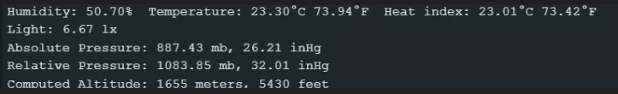

Circuit:

Weather Station is attached to the chassis of remote-control Car.

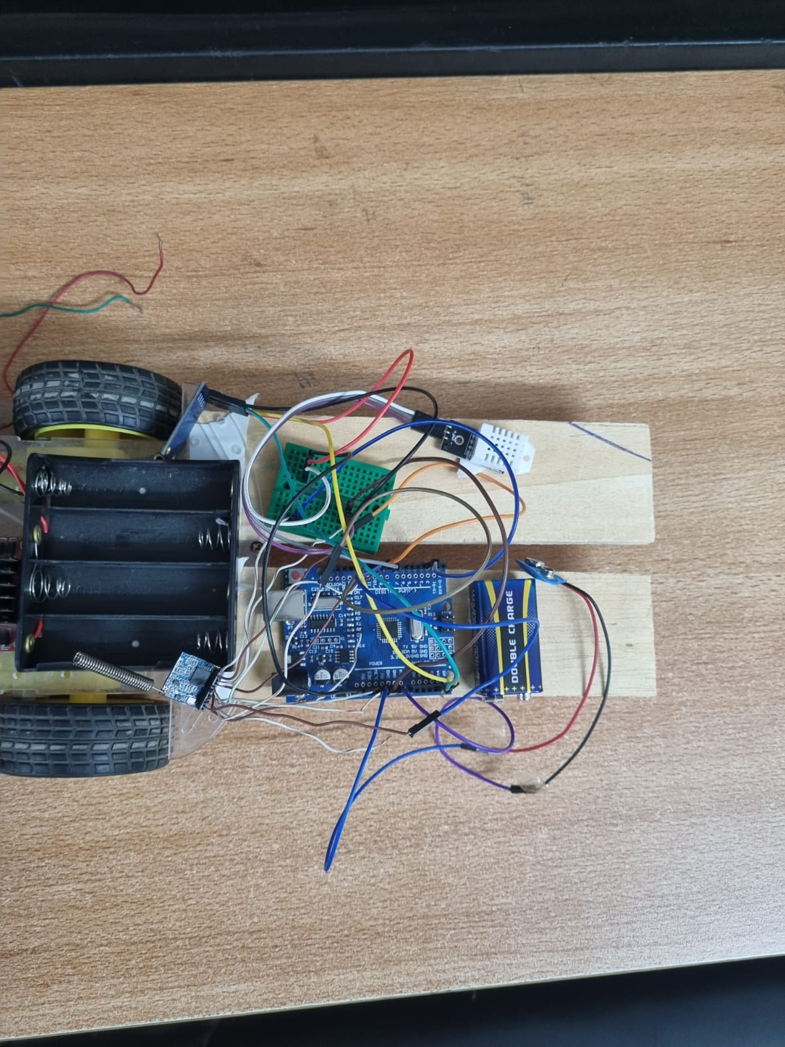

Remote Control car
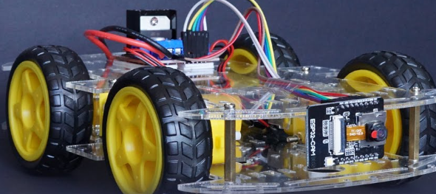
ESP32 Cam is the main microcontroller with integrated Wi-Fi for communication.
Car Chassis
- The physical structure providing a platform for mounting components.
Motors and Wheels (4x)
- Motors control the car's movement, and wheels are attached to the motors for mobility.
L298N Motor Driver
- Controls motor speed and direction. Connects to the ESP32 Cam for control signals.
14 Volts Battery
- Powers motors and the ESP32 Cam.
Connecting Wires
- Establish electrical connections between components.

Connections:
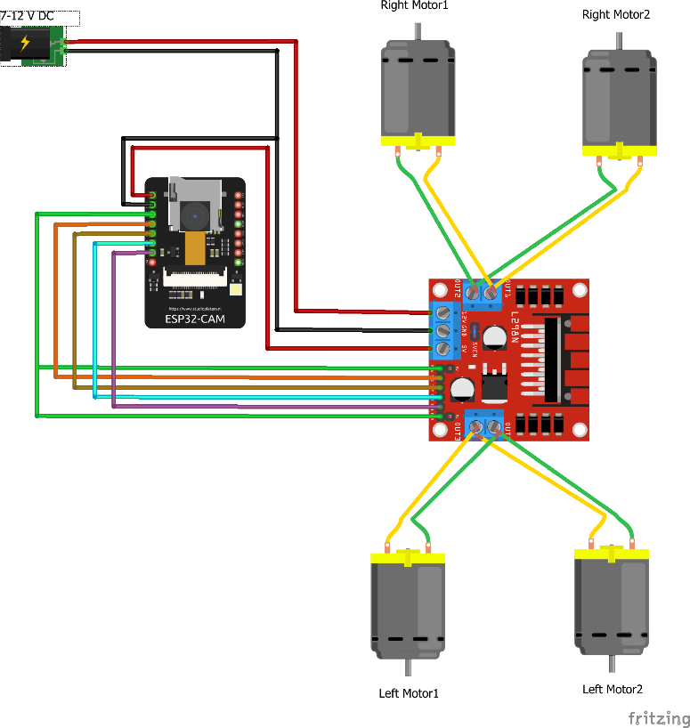
1. Motor Connections
Connect each motor to the L298N Motor Driver:
- Motor 1 to OUT1 and OUT2.
- Motor 2 to OUT3 and OUT4.
- Motor 3 to OUT5 and OUT6.
- Motor 4 to OUT7 and OUT8.

Connect L298N Motor Driver to ESP32 Cam:
- IN1, IN2, IN3, and IN4 to GPIO pins on ESP32 Cam (e.g., D1, D2, D3, D4).
- Connect L298N Motor Driver's VCC and GND to ESP32 Cam's 5V and GND.

2. Power Connections:
- Connect the 14 Volts Battery:
- Connect positive terminal to VCC of L298N Motor Driver.
- Connect negative terminal to GND of L298N Motor Driver.
- Ensure ESP32 Cam is connected to the battery through its own power supply pins.

3. Power Switch:
- Install a power switch between the battery and the rest of the circuit for easy ON/OFF control.

ESP32 Programming:
- Program ESP32 Cam using the Arduino IDE or another suitable IDE.
- Implement logic for controlling motors based on input from a remote control source.
- Set up a Wi-Fi connection for remote control. Here we have coded the ESP32 to act as an Access Point.

Remote Control Interface
- Create a remote control interface using a web-based application, mobile app, or other preferred method.
- Implement controls for forward, backward, left, and right movements.
Operation:
Power On
- Connect the battery to power on the car.
- Connect to Wi-Fi:
- ESP32 Cam connects to a Wi-Fi network, enabling remote control.
Remote Control:
- Use the remote control interface to send commands to ESP32 Cam.
- ESP32 processes commands and controls motors accordingly.
Movement:
- Motors receive signals from ESP32 and move the car based on the received commands.
Considerations:
- Ensure sufficient power supply for both motors and ESP32 Cam.
- Implement proper error handling and safety mechanisms to prevent accidents or damage.
- Test the car in a controlled environment before deploying it in more complex scenarios.

Working:
User Input
- User provides input via the remote control interface (forward, backward, left, right).
- ESP32 Cam processes user input and generates control signals for the motors.
- L298N Motor Driver interprets control signals and adjusts motor speed and direction.
Car Movement
- Motors move the wheels according to the control signals, resulting in the car moving as per user commands.
Code:
#include "esp_camera.h"
#include <Arduino.h>
#include <WiFi.h>
#include <AsyncTCP.h>
#include <ESPAsyncWebServer.h>
#include <iostream>
#include <sstream>

struct MOTOR_PINS
{
int pinEn;
int pinIN1;
int pinIN2;
};

std::vector<MOTOR_PINS> motorPins =
{
{12, 13, 15}, //RIGHT_MOTOR Pins (EnA, IN1, IN2)
{12, 14, 2}, //LEFT_MOTOR Pins (EnB, IN3, IN4)
};
#define LIGHT_PIN 4

#define UP 1
#define DOWN 2
#define LEFT 3
#define RIGHT 4
#define STOP 0

#define RIGHT_MOTOR 0
#define LEFT_MOTOR 1

#define FORWARD 1
#define BACKWARD -1

const int PWMFreq = 1000; /* 1 KHz */
const int PWMResolution = 8;
const int PWMSpeedChannel = 2;
const int PWMLightChannel = 3;

//Camera related constants
#define PWDN_GPIO_NUM 32
#define RESET_GPIO_NUM -1
#define XCLK_GPIO_NUM 0
#define SIOD_GPIO_NUM 26
#define SIOC_GPIO_NUM 27
#define Y9_GPIO_NUM 35
#define Y8_GPIO_NUM 34
#define Y7_GPIO_NUM 39
#define Y6_GPIO_NUM 36
#define Y5_GPIO_NUM 21
#define Y4_GPIO_NUM 19
#define Y3_GPIO_NUM 18
#define Y2_GPIO_NUM 5
#define VSYNC_GPIO_NUM 25
#define HREF_GPIO_NUM 23
#define PCLK_GPIO_NUM 22

const char* ssid = "MyWiFiCar";
const char* password = "12345678";

AsyncWebServer server(80);
AsyncWebSocket wsCamera("/Camera");
AsyncWebSocket wsCarInput("/CarInput");
uint32_t cameraClientId = 0;

const char* htmlHomePage PROGMEM = R"HTMLHOMEPAGE(
<!DOCTYPE html>
<html>
<head>
<meta name="viewport" content="width=device-width, initial-scale=1, maximum-scale=1, user-scalable=no">
<style>
.arrows {
font-size:40px;
color:red;
}
td.button {
background-color:black;
border-radius:25%;
box-shadow: 5px 5px #888888;
}
td.button:active {
transform: translate(5px,5px);
box-shadow: none;
}

.noselect {
-webkit-touch-callout: none; /* iOS Safari */
-webkit-user-select: none; /* Safari */
-khtml-user-select: none; /* Konqueror HTML */
-moz-user-select: none; /* Firefox */
-ms-user-select: none; /* Internet Explorer/Edge */
user-select: none; /* Non-prefixed version, currently
supported by Chrome and Opera */
}

.slidecontainer {
width: 100%;
}

.slider {
-webkit-appearance: none;
width: 100%;
height: 15px;
border-radius: 5px;
background: #d3d3d3;
outline: none;
opacity: 0.7;
-webkit-transition: .2s;
transition: opacity .2s;
}

.slider:hover {
opacity: 1;
}

.slider::-webkit-slider-thumb {
-webkit-appearance: none;
appearance: none;
width: 25px;
height: 25px;
border-radius: 50%;
background: red;
cursor: pointer;
}

.slider::-moz-range-thumb {
width: 25px;
height: 25px;
border-radius: 50%;
background: red;
cursor: pointer;
}

</style>

</head>
<body class="noselect" align="center" style="background-color:white">

<!--h2 style="color: teal;text-align:center;">Wi-Fi Camera &#128663; Control</h2-->

<table id="mainTable" style="width:400px;margin:auto;table-layout:fixed" CELLSPACING=10>
<tr>
<img id="cameraImage" src="" style="width:400px;height:250px"></td>
</tr>
<tr>
<td></td>
<td class="button" ontouchstart='sendButtonInput("MoveCar","1")' ontouchend='sendButtonInput("MoveCar","0")'><span class="arrows" >&#8679;</span></td>
<td></td>
</tr>
<tr>
<td class="button" ontouchstart='sendButtonInput("MoveCar","3")' ontouchend='sendButtonInput("MoveCar","0")'><span class="arrows" >&#8678;</span></td>
<td class="button"></td>
<td class="button" ontouchstart='sendButtonInput("MoveCar","4")' ontouchend='sendButtonInput("MoveCar","0")'><span class="arrows" >&#8680;</span></td>
</tr>
<tr>
<td></td>
<td class="button" ontouchstart='sendButtonInput("MoveCar","2")' ontouchend='sendButtonInput("MoveCar","0")'><span class="arrows" >&#8681;</span></td>
<td></td>
</tr>
<tr/><tr/>
<tr>
<td style="text-align:left"><b>Speed:</b></td>
<td colspan=2>
<div class="slidecontainer">
<input type="range" min="0" max="255" value="150" class="slider" id="Speed" oninput='sendButtonInput("Speed",value)'>
</div>
</td>
</tr>
<tr>
<td style="text-align:left"><b>Light:</b></td>
<td colspan=2>
<div class="slidecontainer">
<input type="range" min="0" max="255" value="0" class="slider" id="Light" oninput='sendButtonInput("Light",value)'>
</div>
</td>
</tr>
</table>

<script>
var webSocketCameraUrl = "ws:\/\/" + window.location.hostname + "/Camera";
var webSocketCarInputUrl = "ws:\/\/" + window.location.hostname + "/CarInput";
var websocketCamera;
var websocketCarInput;

function initCameraWebSocket()
{
websocketCamera = new WebSocket(webSocketCameraUrl);
websocketCamera.binaryType = 'blob';
websocketCamera.onopen = function(event){};
websocketCamera.onclose = function(event){setTimeout(initCameraWebSocket, 2000);};
websocketCamera.onmessage = function(event)
{
var imageId = document.getElementById("cameraImage");
imageId.src = URL.createObjectURL(event.data);
};
}

function initCarInputWebSocket()
{
websocketCarInput = new WebSocket(webSocketCarInputUrl);
websocketCarInput.onopen = function(event)
{
var speedButton = document.getElementById("Speed");
sendButtonInput("Speed", speedButton.value);
var lightButton = document.getElementById("Light");
sendButtonInput("Light", lightButton.value);
};
websocketCarInput.onclose = function(event){setTimeout(initCarInputWebSocket, 2000);};
websocketCarInput.onmessage = function(event){};
}

function initWebSocket()
{
initCameraWebSocket ();
initCarInputWebSocket();
}

function sendButtonInput(key, value)
{
var data = key + "," + value;
websocketCarInput.send(data);
}

window.onload = initWebSocket;
document.getElementById("mainTable").addEventListener("touchend", function(event){
event.preventDefault()
});
</script>
</body>
</html>
)HTMLHOMEPAGE";

void rotateMotor(int motorNumber, int motorDirection)
{
if (motorDirection == FORWARD)
{
digitalWrite(motorPins[motorNumber].pinIN1, HIGH);
digitalWrite(motorPins[motorNumber].pinIN2, LOW);
}
else if (motorDirection == BACKWARD)
{
digitalWrite(motorPins[motorNumber].pinIN1, LOW);
digitalWrite(motorPins[motorNumber].pinIN2, HIGH);
}
else
{
digitalWrite(motorPins[motorNumber].pinIN1, LOW);
digitalWrite(motorPins[motorNumber].pinIN2, LOW);
}
}

void moveCar(int inputValue)
{
Serial.printf("Got value as %d\n", inputValue);
switch(inputValue)
{

case UP:
rotateMotor(RIGHT_MOTOR, FORWARD);
rotateMotor(LEFT_MOTOR, FORWARD);
break;

case DOWN:
rotateMotor(RIGHT_MOTOR, BACKWARD);
rotateMotor(LEFT_MOTOR, BACKWARD);
break;

case LEFT:
rotateMotor(RIGHT_MOTOR, FORWARD);
rotateMotor(LEFT_MOTOR, BACKWARD);
break;

case RIGHT:
rotateMotor(RIGHT_MOTOR, BACKWARD);
rotateMotor(LEFT_MOTOR, FORWARD);
break;

case STOP:
rotateMotor(RIGHT_MOTOR, STOP);
rotateMotor(LEFT_MOTOR, STOP);
break;

default:
rotateMotor(RIGHT_MOTOR, STOP);
rotateMotor(LEFT_MOTOR, STOP);
break;
}
}

void handleRoot(AsyncWebServerRequest *request)
{
request->send_P(200, "text/html", htmlHomePage);
}

void handleNotFound(AsyncWebServerRequest *request)
{
request->send(404, "text/plain", "File Not Found");
}

void onCarInputWebSocketEvent(AsyncWebSocket *server,
AsyncWebSocketClient *client,
AwsEventType type,
void *arg,
uint8_t *data,
size_t len)
{
switch (type)
{
case WS_EVT_CONNECT:
Serial.printf("WebSocket client #%u connected from %s\n", client->id(), client->remoteIP().toString().c_str());
break;
case WS_EVT_DISCONNECT:
Serial.printf("WebSocket client #%u disconnected\n", client->id());
moveCar(0);
ledcWrite(PWMLightChannel, 0);
break;
case WS_EVT_DATA:
AwsFrameInfo *info;
info = (AwsFrameInfo*)arg;
if (info->final && info->index == 0 && info->len == len && info->opcode == WS_TEXT)
{
std::string myData = "";
myData.assign((char *)data, len);
std::istringstream ss(myData);
std::string key, value;
std::getline(ss, key, ',');
std::getline(ss, value, ',');
Serial.printf("Key [%s] Value[%s]\n", key.c_str(), value.c_str());
int valueInt = atoi(value.c_str());
if (key == "MoveCar")
{
moveCar(valueInt);
}
else if (key == "Speed")
{
ledcWrite(PWMSpeedChannel, valueInt);
}
else if (key == "Light")
{
ledcWrite(PWMLightChannel, valueInt);
}
}
break;
case WS_EVT_PONG:
case WS_EVT_ERROR:
break;
default:
break;
}
}

void onCameraWebSocketEvent(AsyncWebSocket *server,
AsyncWebSocketClient *client,
AwsEventType type,
void *arg,
uint8_t *data,
size_t len)
{
switch (type)
{
case WS_EVT_CONNECT:
Serial.printf("WebSocket client #%u connected from %s\n", client->id(), client->remoteIP().toString().c_str());
cameraClientId = client->id();
break;
case WS_EVT_DISCONNECT:
Serial.printf("WebSocket client #%u disconnected\n", client->id());
cameraClientId = 0;
break;
case WS_EVT_DATA:
break;
case WS_EVT_PONG:
case WS_EVT_ERROR:
break;
default:
break;
}
}

void setupCamera()
{
camera_config_t config;
config.ledc_channel = LEDC_CHANNEL_0;
config.ledc_timer = LEDC_TIMER_0;
config.pin_d0 = Y2_GPIO_NUM;
config.pin_d1 = Y3_GPIO_NUM;
config.pin_d2 = Y4_GPIO_NUM;
config.pin_d3 = Y5_GPIO_NUM;
config.pin_d4 = Y6_GPIO_NUM;
config.pin_d5 = Y7_GPIO_NUM;
config.pin_d6 = Y8_GPIO_NUM;
config.pin_d7 = Y9_GPIO_NUM;
config.pin_xclk = XCLK_GPIO_NUM;
config.pin_pclk = PCLK_GPIO_NUM;
config.pin_vsync = VSYNC_GPIO_NUM;
config.pin_href = HREF_GPIO_NUM;
config.pin_sscb_sda = SIOD_GPIO_NUM;
config.pin_sscb_scl = SIOC_GPIO_NUM;
config.pin_pwdn = PWDN_GPIO_NUM;
config.pin_reset = RESET_GPIO_NUM;
config.xclk_freq_hz = 20000000;
config.pixel_format = PIXFORMAT_JPEG;

config.frame_size = FRAMESIZE_VGA;
config.jpeg_quality = 10;
config.fb_count = 1;

// camera init
esp_err_t err = esp_camera_init(&config);
if (err != ESP_OK)
{
Serial.printf("Camera init failed with error 0x%x", err);
return;
}

if (psramFound())
{
heap_caps_malloc_extmem_enable(20000);
Serial.printf("PSRAM initialized. malloc to take memory from psram above this size");
}
}

void sendCameraPicture()
{
if (cameraClientId == 0)
{
return;
}
unsigned long startTime1 = millis();
//capture a frame
camera_fb_t * fb = esp_camera_fb_get();
if (!fb)
{
Serial.println("Frame buffer could not be acquired");
return;
}

unsigned long startTime2 = millis();
wsCamera.binary(cameraClientId, fb->buf, fb->len);
esp_camera_fb_return(fb);

//Wait for message to be delivered
while (true)
{
AsyncWebSocketClient * clientPointer = wsCamera.client(cameraClientId);
if (!clientPointer || !(clientPointer->queueIsFull()))
{
break;
}
delay(1);
}

unsigned long startTime3 = millis();
Serial.printf("Time taken Total: %d|%d|%d\n",startTime3 - startTime1, startTime2 - startTime1, startTime3-startTime2 );
}

void setUpPinModes()
{
//Set up PWM
ledcSetup(PWMSpeedChannel, PWMFreq, PWMResolution);
ledcSetup(PWMLightChannel, PWMFreq, PWMResolution);

for (int i = 0; i < motorPins.size(); i++)
{
pinMode(motorPins[i].pinEn, OUTPUT);
pinMode(motorPins[i].pinIN1, OUTPUT);
pinMode(motorPins[i].pinIN2, OUTPUT);

/* Attach the PWM Channel to the motor enb Pin */
ledcAttachPin(motorPins[i].pinEn, PWMSpeedChannel);
}
moveCar(STOP);

pinMode(LIGHT_PIN, OUTPUT);
ledcAttachPin(LIGHT_PIN, PWMLightChannel);
}

void setup(void)
{
setUpPinModes();
Serial.begin(115200);

WiFi.softAP(ssid, password);
IPAddress IP = WiFi.softAPIP();
Serial.print("AP IP address: ");
Serial.println(IP);

server.on("/", HTTP_GET, handleRoot);
server.onNotFound(handleNotFound);

wsCamera.onEvent(onCameraWebSocketEvent);
server.addHandler(&wsCamera);

wsCarInput.onEvent(onCarInputWebSocketEvent);
server.addHandler(&wsCarInput);

server.begin();
Serial.println("HTTP server started");

setupCamera();
}

void loop()
{
wsCamera.cleanupClients();
wsCarInput.cleanupClients();
sendCameraPicture();
Serial.printf("SPIRam Total heap %d, SPIRam Free Heap %d\n", ESP.getPsramSize(), ESP.getFreePsram());
}

Receiver Circuit:
It comprises of another Arduino attached to LoRa transceiver module that will receive the packets sent by weather station and will display received data on serial monitor. LoRa transceiver is connected to Arduino as follows:

Connections:
- VCC to 3.3V on Arduino.
- GND to GND on Arduino.
- MISO to D12 on Arduino.
- MOSI to D11 on Arduino.
- SCK to D13 on Arduino.
- NSS/CS to D10 on Arduino.
- DIO0 to D2 on Arduino (for interrupt signaling).
Code:
#include <SPI.h>
#include <LoRa.h>

void setup()
{
Serial.begin(9600);
while (!Serial);
Serial.println("LoRa Receiver");
if (!LoRa.begin(433E6)) {
Serial.println("Starting LoRa failed!");
while (1);
}
}

void loop() {
// try to parse packet
int packetSize = LoRa.parsePacket();
if (packetSize)
{
// received a paket
Serial.println("");
Serial.println("...................................");
Serial.println("Received packet: ");

// read packet
while (LoRa.available()) {
char incoming = (char)LoRa.read();
if (incoming == 'c')
{
Serial.print("Error");
}
else
{
Serial.print(incoming);
}
}
}
}

Conclusion:
In the culmination of the Remote Control Weather Detection Car project, the successful integration of cutting-edge technologies has resulted in a sophisticated and adaptable system. The combination of an ESP32 microcontroller, weather sensors (DHT22, BH1750), and a LoRa transceiver has created a mobile platform capable of not only remote control but also real-time weather monitoring. This innovative solution caters to a spectrum of applications, from environmental data collection to responsive mobility in changing weather conditions.

